- 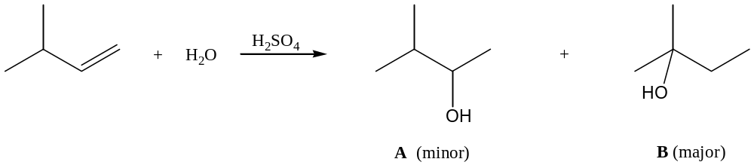Consider the following acid-catalyzed hydration of an alkene. When the reaction products were examined, the expected product (A) was formed in low yield. Another product (B) was formed preferentially.

Write the step-wise mechanism, showing all curved arrows and intermediates, for this reaction and explain why the expected product A is formed in lower yield than product B.

Carbocation rearrangement gives a more stable carbocation intermediate, which leads to produce B.

- In the reaction shown below, only one product is formed. Why? What is the difference between this reaction and the previous one?
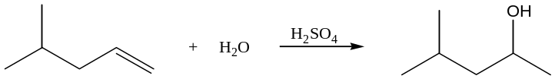

There is no rearrangement. Only the Markovnikov product is formed.
3. Consider the following reaction.
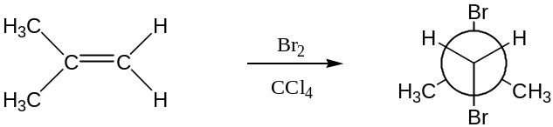

- What is the IUPAC name for the starting material in this reaction? What is the stereochemistry of the starting material (if there is any)?

2-methylpropene; there is no stereochemistry

- What is the IUPAC name for the product in this reaction?

1,2-dibromo-2-methylpropane

- Show the mechanism for the formation of the dibromoalkane.

Br⁻ can attack either C and will give the same product

- In the presence of water, the formation of a second product is also observed. Draw this product, clearly showing all regio- and stereochemistry.

- In the following portion of the hydroboration reaction, give a complete mechanism for how the highlighted material (in the box) is formed from the reactant on the left.

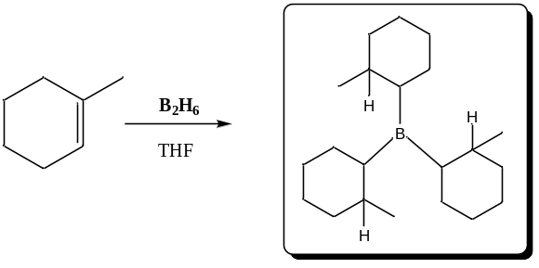

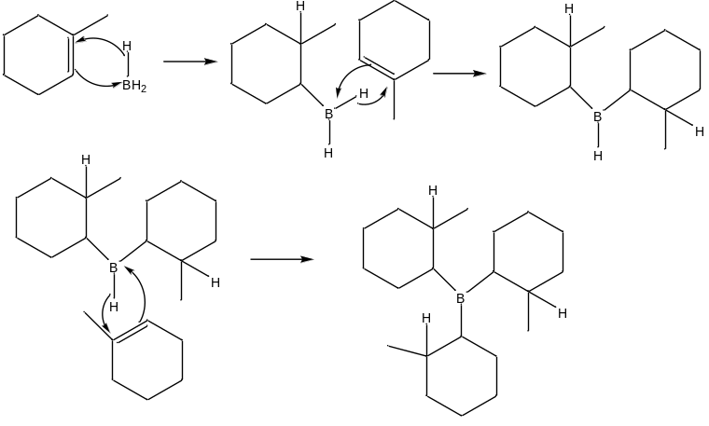
- Provide a detailed mechanism for the formation of the product in the box below.

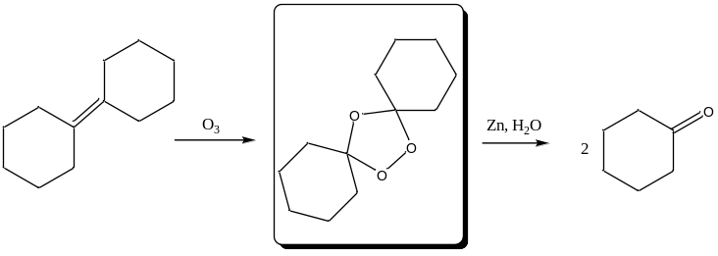
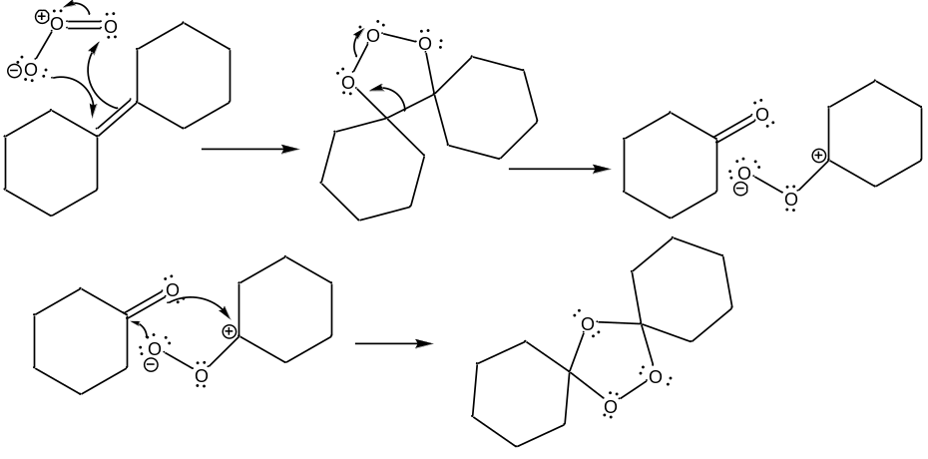
4. Draw the major organic product formed (showing stereochemistry where applicable) for the reaction of the following alkene under each of the reaction conditions listed below.

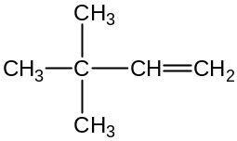

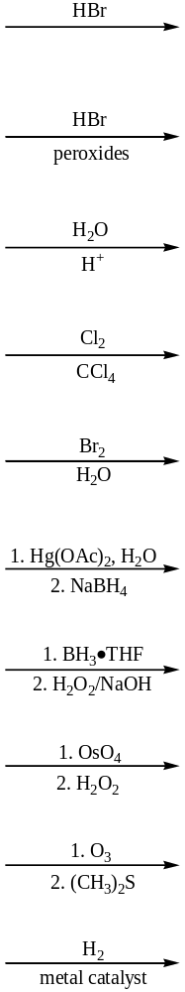

5. Draw the major organic product formed (showing stereochemistry where applicable) for the reaction of the following cycloalkene under each of the reaction conditions listed below.

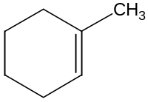

- Draw the starting material and reagents used to form the following products, using reactions studied in Wade, Chapter 8. Note: there may be more than one correct answer.

u)

v)

w)

x)

y)

z)

